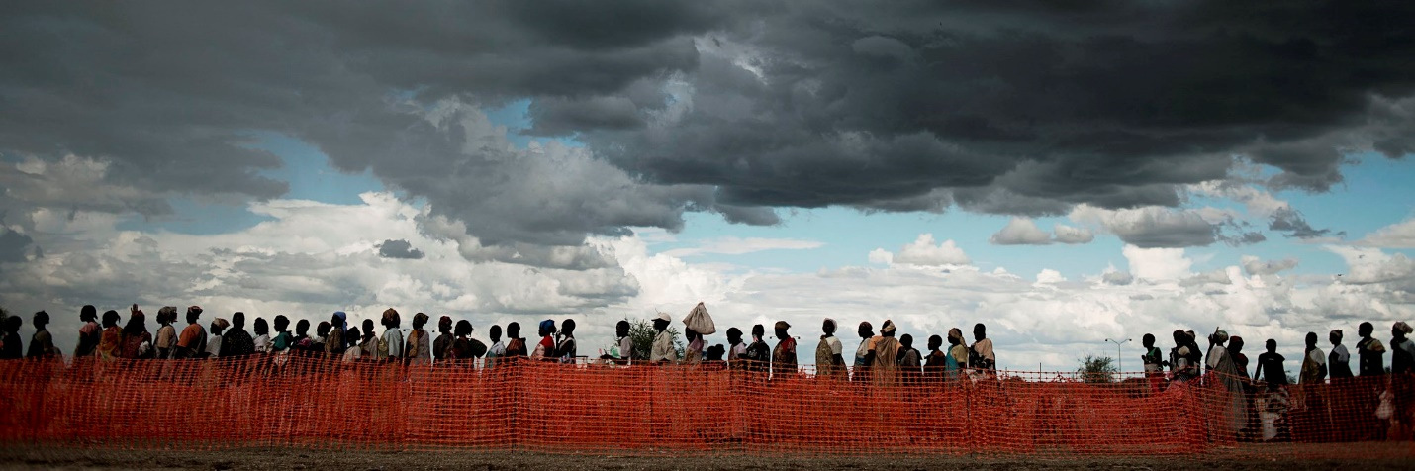
HR Manager
Who are we?
The Danish Refugee Council (DRC) is an International non-governmental organisation, which promotes and supports durable solutions to the problems faced by refugees and internally displaced people worldwide.
DRC has been actively assisting people and communities affected by the current Syrian crisis since 2011, with programmes in support of Syrians in Lebanon, Jordan, Turkey and of course Syria.
The DRC Syria programme, headquartered in Damascus, currently have 9 expatriate staff and more than 376 national employees – some of which are based at the DRC Community Centres located in 5 different areas throughout the country.

About the job
Lead and manage Human Resources functions. Provide overall advice, coordination and management to the Human Resources team. Ensure efficient support to the program in accordance with existing DRC policies and procedures.

Duties and Responsibilities
HR Management
• Lead and manage the Human Resources team (including people planning, performance, well-being and development)
• Provide technical support, advice and capacity build the Human Resources team
• Advise and assist managers in Human Resources related issues and concerns

Recruitment, development and people planning
• Drive and support recruitment and selection activities ensuring compliance with recruitment process
• Work with senior management team and senior staff on new staff retention strategies and initiatives
• Ensure proper onboarding process
• Ensure oversight and consistency in position titles and grades, across all field locations
• Support staff development activities including promoting DRC Learning Catalogue
• Assist managers to identify, recommend and approve Learning & Development initiatives for their employees through DRC’s Learning Catalogue.

Performance, well-being and compensations & benefits
• Proactively respond to and manage performance counselling, employee grievances and disciplinary issues as required, with a focus on building manager competency and ensuring that documentation is kept
• Lead the performance management process
• Act as an impartial mediator in disciplinary procedures and ensure it is administered in an equitable and fair manner and meets all legal and labor regulations and requirements
• Lead people well-being initiatives
• Define and review salary structure in partnership with the Senior Management team and coordinate annual compensation review process and compensation adjustments
• Ensure that monthly payroll process is efficient and that salaries, social security and taxes are paid in line with Local Law.

Human Resources Policies and Support
• Maintain and update Staff Human Resources Handbooks as necessary taking into consideration compliance with the local labor law and DRC general policies.
• Proactively pursue continuous process improvement in Human Resources related practices in order to enhance the quality and efficiency of output/delivery.
• Work closely with regional office/ head quarter to share information and provide support as required

Administration
• Coordinate with DRC Legal Advisor on all issues related to labor law, making sure that DRC Syria is compliant with the labor law requirements
• Ensure having accurate and up-to-date HR data/records on ERP
• Ensure oversight of relevant lists (e.g. leave, RR) in coordination with managers and field sites
• Monitor contract end dates and proactively liaise with managers regarding extension or end of contract
• Coordinate the exit process

About you
To be successful in this role you must have:
• Master’s degree in Human Resource Management, Business, Law or Social Science.
• Minimum 5 years working experience in Human Resources with at least 2 years in a senior Human Resources management role in large organizations or INGOs.
• At least 3 years of experience in people management
• Proven leadership skills and a competence in people management
• Demonstrated understanding and working knowledge/experience of Human Resources Management principles, concepts & processes
• Extensive knowledge on local labor law
• Excellent skills in handling and advising on complex people management issues
• Experience in developing Human Resources strategies and policies, and driving implementation
• Experience using HR Information System or ERP
• Full professional proficiency in English

In this position, you are expected to demonstrate DRC’ five core competencies:
Striving for excellence: You focus on reaching results while ensuring an efficient process.
Collaborating: You involve relevant parties and encourage feedback.
Taking the lead: You take ownership and initiative while aiming for innovation.
Communicating: You listen and speak effectively and honestly.
Demonstrating integrity: You act in line with our vision and values.

We offer
DRC will offer the successful applicant a up to 6 months contract, renewable dependent on both funding and performance. You must be available to start work as soon as possible and be willing and able to work in Damascus, Syria.
Salary and conditions will be in accordance with Danish Refugee Council’s Terms of Employment for Nationals;

Application process
Interested? Then apply for this position by clicking on the apply button.
All applicants must send a cover letter and an updated CV (no longer than four pages). Both must be in the same language as this vacancy note. CV only applications will not be considered.
If you have questions or are facing problems with the online application process, please contact job@drc.dk
Applications close: October 20, 2018.
Please note that due to the urgency of the post, applications will be reviewed on a rolling basis. Early applications are strongly encouraged.

Need further information?
For further information about the Danish Refugee Council, please consult our website www.drc.ngo

If you have questions or are facing problems with the online application process, please visit drc.ngo/jobsupport.

