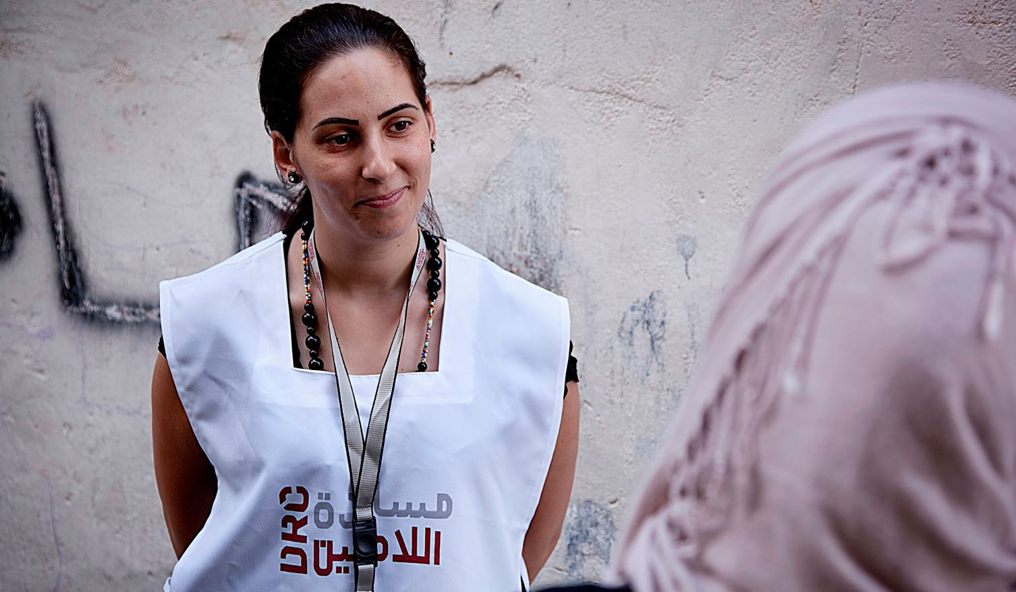
Site Worker
Danish Refugee Council, one of the world’s leading humanitarian NGOs, is currently looking for a highly qualified individual to provide a service in the Humanitarian field as Site Worker in Aleppo
Who are we?
The Danish Refugee Council assists refugees and internally displaced persons across the globe: we provide emergency aid, fight for their rights, and strengthen their opportunity for a brighter future. We work in conflict-affected areas, along the displacement routes, and in the countries where refugees settle. In cooperation with local communities, we strive for responsible and sustainable solutions. We work toward successful integration and – whenever possible – for the fulfillment of the wish to return home.
The Danish Refugee Council was founded in Denmark in 1956, and has since grown to become an international humanitarian organization with more than 7,000 staff and 8,000 volunteers. Our vision is a dignified life for all displaced.
All of our efforts are based on our value compass: humanity, respect, independence and neutrality, participation, and honesty and transparency.

DRC Syria
DRC has been actively operating in Syria since 2008 mainly supporting refugees. In June 2012, DRC was authorized by the Syrian Ministry of Foreign Affairs (MoFA) to expand its humanitarian efforts and provide assistance to IDPs and the vulnerable resident population countrywide. Since then, DRC activities have been focused on NFI distributions, Shelter, WASH, Protection, Education, Livelihoods and Mine Risk Education in six Governorates (Damascus, Rural Damascus, Dara'a, Aleppo, Hama, and Homs). While Protection/community service activities are provided to beneficiaries throughout our six Community Centers.

Overview of the Tasks:
Support the engineers at the site in conducting interviews with IDPs and as required for monitoring purpose.
Tasks in Details:
- Interviewing IDPs of the DRC shelter project.
- Conducting assessments on the occupancy rate for finalized DRC shelters.
- Provide support to the Chief Engineer and Assistant Engineer during the monitoring and supervision process as requested.
- Take photos, do measurements, draw sketch, as per request by Assistant Engineer and Chief Engineer.

About you
To be successful in this role we expect you to have
Required
- Engineering institute.
- One – two years of experience in construction domain.
- Excellent command of the Arabic language
Desirable
- Basics of AutoCAD

In this position, you are expected to demonstrate DRC’ five core competencies:
Striving for excellence: You focus on reaching results while ensuring an efficient process.
Collaborating: You involve relevant parties and encourage feedback.
Taking the lead: You take ownership and initiative while aiming for innovation.
Communicating: You listen and speak effectively and honestly.
Demonstrating integrity: You act in line with our vision and values.

We offer
Contract Length: three months contract, renewable dependent on both funding and performance.
According to the policy of the Danish Refugee Council service contract, payment will be made according to the working hours
Due to legal requirements, we are only allowed to consider applicants with Syrian or Syrian Palestinian nationality
Female candidates are highly encouraged to apply
Application process
Interested? Then apply for this position, go to
https://candidate.hr-manager.net/ApplicationInit.aspx?cid=1036&ProjectId=155323&DepartmentId=19001&MediaId=5
And click on "Apply for position".
All applicants must upload a cover letter and an updated CV (no longer than four pages) in English. Applications sent by email will not be considered.
Closing date for applications: the 26th of February 2019.
Need further information?
For further information about the Danish Refugee Council, please consult our website drc.ngo.

