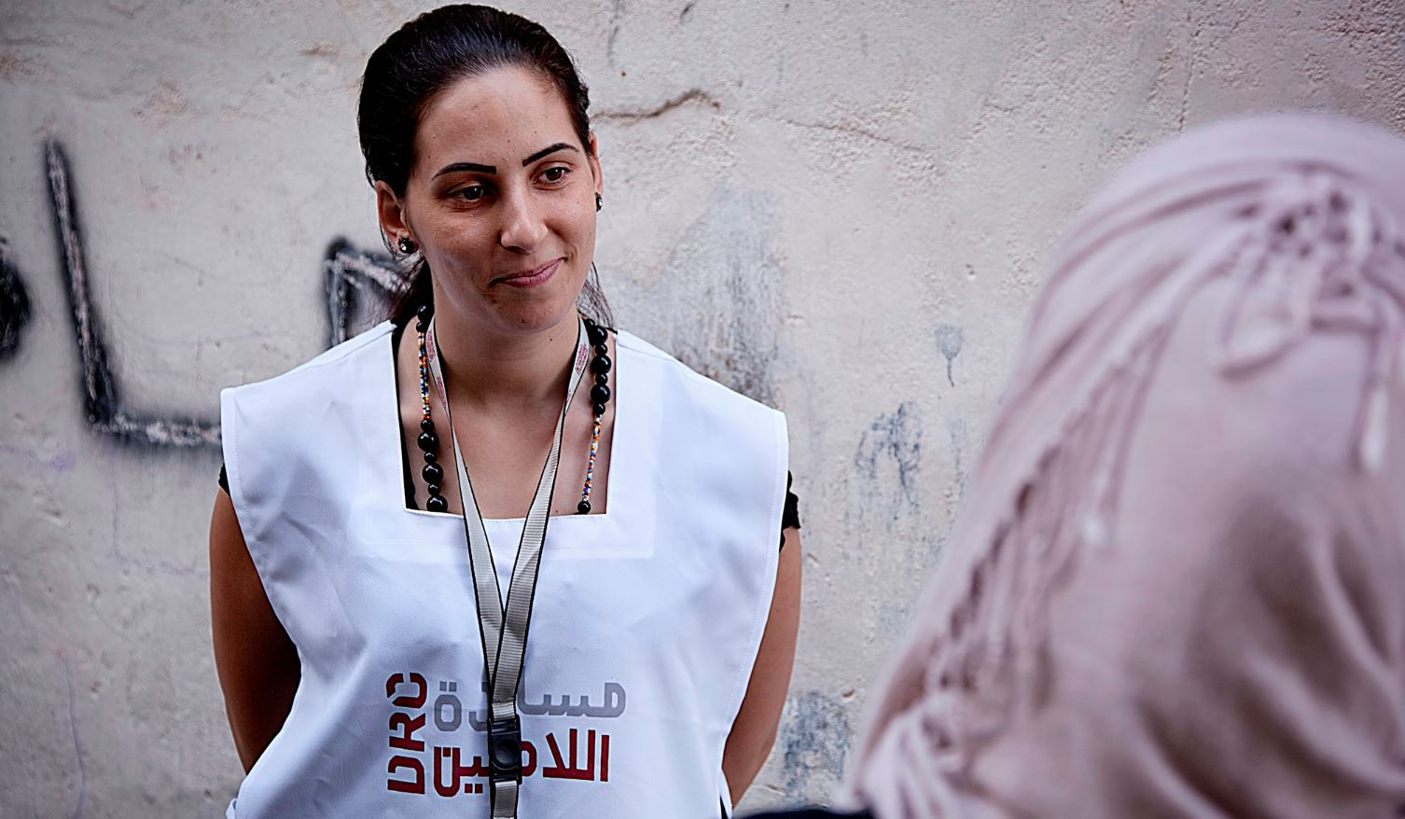
Livelihoods Field Assistant - Micro Grants

Danish Refugee Council, one of the world’s leading humanitarian NGOs, is currently looking for a highly qualified individual to provide a service in the Humanitarian field as Livelihoods Field Assistant -Micro Grants in Rural Damascus and Damascus
Who are we?
The Danish Refugee Council assists refugees and internally displaced persons across the globe: we provide emergency aid, fight for their rights, and strengthen their opportunity for a brighter future. We work in conflict-affected areas, along the displacement routes, and in the countries where refugees settle. In cooperation with local communities, we strive for responsible and sustainable solutions. We work toward successful integration and – whenever possible – for the fulfillment of the wish to return home.
The Danish Refugee Council was founded in Denmark in 1956, and has since grown to become an international humanitarian organization with more than 7,000 staff and 8,000 volunteers. Our vision is a dignified life for all displaced.
All of our efforts are based on our value compass: humanity, respect, independence and neutrality, participation, and honesty and transparency.
DRC Syria
DRC has been actively operating in Syria since 2008 mainly supporting refugees. In June 2012, DRC was authorized by the Syrian Ministry of Foreign Affairs (MoFA) to expand its humanitarian efforts and provide assistance to IDPs and the vulnerable resident population countrywide. Since then, DRC activities have been focused on NFI distributions, Shelter, WASH, Protection, Education, Livelihoods and Mine Risk Education in six Governorates (Damascus, Rural Damascus, Dara'a, Aleppo, Hama, and Homs). While Protection/community service activities are provided to beneficiaries throughout our six Community Centers.

Overview of the Tasks:
Implement DRC Syria’s Livelihoods interventions in the DRC are of intervention; focusing on Micro Grants

Tasks in Details:
Technical:
- Receive micro grants applicants and advise on the activity, process and pre-requisites to apply for the programme;
- Attend and follow up on business development skills training phase including attendance by personal signature for each beneficiary ( signature matching), assessment of the quality of the training and administer beneficiary and trainer/ center feedback through regular documentation;
- Provide coaching to each micro grant/ asset replacement beneficiary on regular basis (twice a month for 6 months) using DRC tools
- Organize and support panel without interfering in the selection of candidates and adopt a non-bias attitude that reflects DRC’s integrity and transparency throughout the process;
- Facilitate and observe technical skills test and center/ trainer documentation;
- Oversee the scale of technical test assessment and test content ensuring non-bias and relevance;
- Explain micro grant contract and liability in terms of commitment to agreed business plan and ownership of assets;
- Identify other technical support required and how to meet it as part of the coaching plan;
- Visit businesses, where feasible and link trades within the same sector;
- Create small professional exchange groups or “Communities of Practice” between similar micro grants/ asset replacement recipients;
- Conduct contract review meetings with beneficiaries;
- Support the establishment of approval mechanisms for micro grants/ asset replacements;
- Support incoming consultants where needed;
- Accompany beneficiary during micro grant purchase – in case of derogation;
- Registration on Sigma system
- Continuous counselling
- Attend DRC livelihoods team micro grant technical work group and contribute input on activity and documentation for design and M&E development;
- Contribute to relevant informal labor market needs assessment and monitor demand on trades and relevant livelihoods opportunities;
- Support the monitoring of other livelihoods activities as requested by line management;
- Any additional task assigned by DRC in regards to livelihoods activities.
General:
- Donors: Understand donor requirements and apply within activity implementation
- Work plans: Understand, and implement activities agreed work plan/ implementation plan with Field Supervisor
- Reporting: Produce reporting inputs, per agreed reporting schedule and formats agreed with Field Supervisor; enter beneficiary data into Sigma, document livelihoods counselling and follow-up/ assessment reports;
- Delivery of targets: Understand targets agreed with the Field Supervisor
- Procurement: Liaise with trainers and field supervisor to finalize English and Arabic specifications and requirements
- Familiarize with, understand and comply with DRC’s administrative, logistics & procurement & financial SOPs
- Monitoring: Understand and cooperate with monitoring initiatives; use monitoring tools (including FGDs, questionnaires, etc), and Sigma; produce monitoring reports; amend implementation based on feedback elicited through monitoring and agreed changes with Field Supervisor
- Selection/targeting: Deliver Livelihoods Counselling to beneficiaries and produce a Livelihoods Plan per beneficiary; understand LLHs range of activities; fully cooperate with and support rollout of DRC registration tool; receive training on new tools
- Evaluation, learning and research: engage with field/documentation requirements as agreed with Field Supervisor
- HR: Manage the trainers or subcontractors within the relevant activities
- Internal cooperation: Regularly update field supervisor with support requirements at activity level, activity progress/deviation
- External representation and coordination: deputize for field supervisor, as requested

About you
To be successful in this role we expect you to have
Required
- Associate degree in business administration or similar field
- One year of relevant experience in a field that is relevant to livelihoods aspects such as training, vocations and professions, counselling and interviewing, follow-up, documentation and reporting;
- Very good oral and written communication skills;
- Good written English skills
- Fluent in Arabic language
- MS Office package literacy;
- Well organized, patient and familiar with humanitarian work;
- Training courses in fields relevant to humanitarian response and aid
Desirable
- University degree in business administration or any relevant field

In this position, you are expected to demonstrate DRC’ five core competencies:
Striving for excellence: You focus on reaching results while ensuring an efficient process.

Collaborating: You involve relevant parties and encourage feedback.

Taking the lead: You take ownership and initiative while aiming for innovation.

Communicating: You listen and speak effectively and honestly.

Demonstrating integrity: You act in line with our vision and values.

We offer
Contract Length: three months contract, renewable dependent on both funding and performance.
According to the policy of the Danish Refugee Council service contract, payment will be made according to the working hours
Working Hours: minimum of 70h/month up to a max of 170h per month including Saturdays
Due to legal requirements, we are only allowed to consider applicants with Syrian or Syrian Palestinian nationality
Precedence is given to applicant with volunteering experience in similar fields
We encourage the application of people with disabilities.

Application process
Interested? Then apply for this position, go to
https://candidate.hr-manager.net/ApplicationInit.aspx?cid=1036&ProjectId=153154&DepartmentId=19001&MediaId=5
And click on "Apply for position".
All applicants must upload a cover letter and an updated CV (no longer than four pages) in English. Applications sent by email will not be considered.
Closing date for applications: the 21st of October 2018.
Need further information?
For further information about the Danish Refugee Council, please consult our website drc.ngo.

