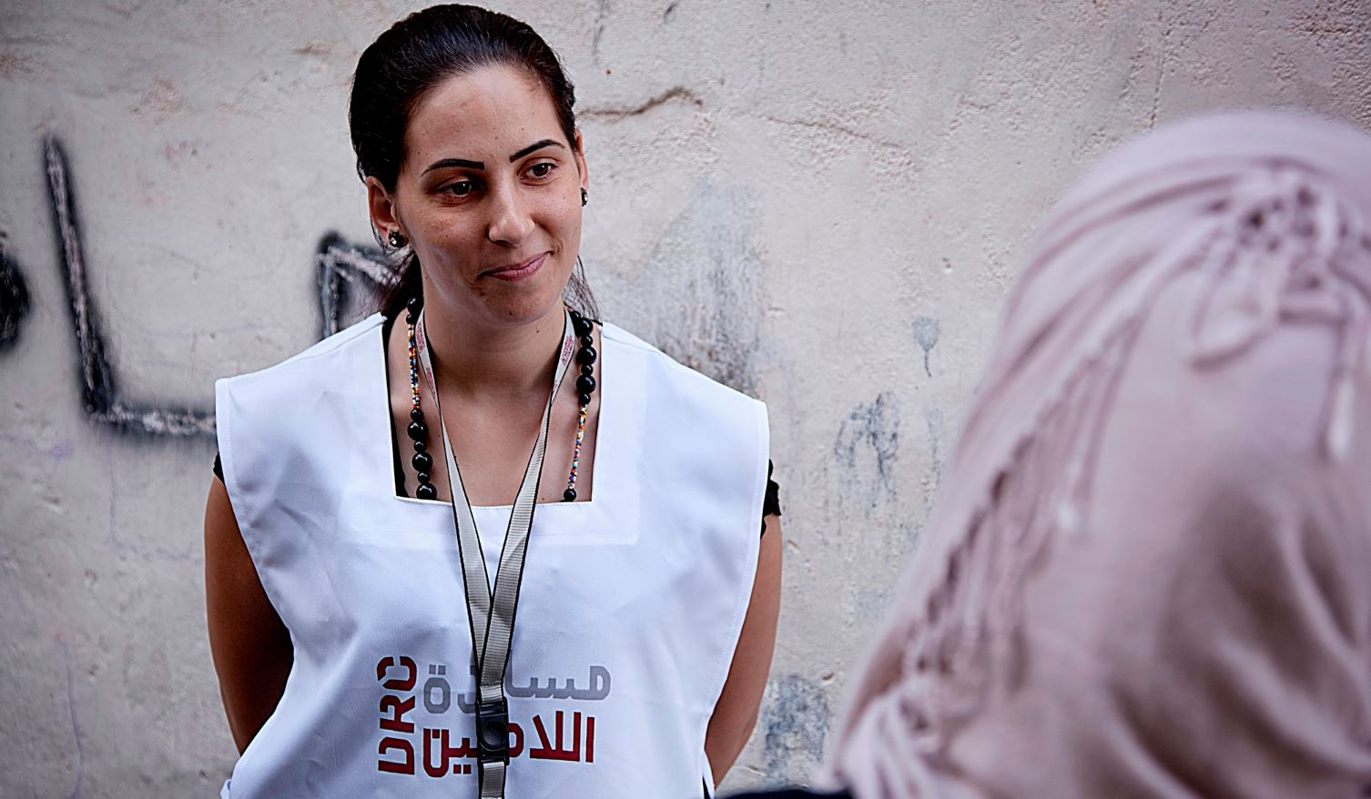

Education program Field Assistant
Homs, Syria
Danish Refugee Council, one of the world’s leading humanitarian NGOs, is currently looking for a highly qualified individual to fill-in the vacancy of Education Program Field Assistant to work in Homs under Service contract
Who are we?
The Danish Refugee Council assists refugees and internally displaced persons across the globe: we provide emergency aid, fight for their rights, and strengthen their opportunity for a brighter future. We work in conflict-affected areas, along the displacement routes, and in the countries where refugees settle. In cooperation with local communities, we strive for responsible and sustainable solutions. We work toward successful integration and – whenever possible – for the fulfillment of the wish to return home.
The Danish Refugee Council was founded in Denmark in 1956, and has since grown to become an international humanitarian organization with more than 7,000 staff and 8,000 volunteers. Our vision is a dignified life for all displaced.
All of our efforts are based on our value compass: humanity, respect, independence and neutrality, participation, and honesty and transparency.
About the job
The Education Programme Field Assistant, in coordination and cooperation with the supporting staff, and supervised by the Education Programme Officer, is substantially expected to:
Function as a Field Monitor providing professional expertise and operational assistance for the education programme development, as well as different tasks as delegated by Education Programme Officer, Coordinator, and/or PM.

Your main duties and responsibilities will be:
- Liaising between school administration and Programme management.
- Daily monitoring of the implementation of remedial classes at the appointed school(s).
- Collect the required data regarding the implementation of programme according to the endorsed official templates from school principals.
- Reporting implementation progress, existing challenges, and required data to the Programme Officer.
- Follow up on delivery of kits to schools and supervise stationery distribution to students.
- Represent DRC’s Q.E Programme at the schools; reflecting DRC’s image and values.
- Conduct preliminary meetings with school staff conveying the project’s methodology of implementation, values, and messages.
- Ensure delivery of required project formats to schools; ensure completion of such formats by school staff on time, and collecting the information upon completion.
- Arrange for and attend meetings with school principals and teachers as requested or upon need.
- Conduct daily field visits to Remedial Classes to take documentary photos.
- Conduct focus group discussions with school principals, teachers, students, and parents to get their feedback under the supervision of MoE and Programme’s management.
- Ensure conducting pre-tests & post-tests on time and collect tests data.
- Assist in creating and developing the necessary formats, procedures, or operations to ensure proper implementation based on observation and feedback from students and school staff.
- Data entry when needed.
- Attend and supervise teachers’ training.
- Provide half-monthly reports concerning the project’s progress and problems as well as the beneficiaries’ to the concerned superiors.
- Immediately inform the QE concerned superior of any out-of-the ordinary cases at schools including severe violations of the operational instructions and/or change of security status which threatens the safety of the beneficiaries or the school staff.
- Send collected data to Programme Officer on time as requested via email.
- Suggest any improvements via providing feasible feedback based on field visits and schools’ needs on the ground.
- Commit to continuous training and learning to develop the Education activities
- Perform any other tasks requested by the QE Programme management.
About you
In this position, you are expected to demonstrate DRC’s core competencies:
Striving for excellence: You focus on reaching results while ensuring an efficient process.
Collaborating: You involve relevant parties and encourage feedback.
Communicating: You listen and speak effectively and honestly.
Demonstrating integrity: You act in line with our vision and values.

To be successful in this role you must have:

Required
- Higher Institute or Bachelor’s Degree.
- Minimum of one year experience with local NGOs, INGOs or UN Agencies.
- Good command of spoken and written English and Arabic languages.

Desirable
- Bachelor’s degree in Education.
- Minimum of two years’ experience with local NGOs, INGOs or UN Agencies, or teaching experience.

We offer
Contract length: three month contract, renewable dependent on both funding and performance.
Salary and conditions will be in accordance with Danish Refugee Council’s Terms of Service contract scale
Due to legal requirements, we are only allowed to consider applicants with Syrian or Syrian Palestinian nationality or for non-Syrians it is required a valid work permit within Syria.
Application process
Interested? Then apply for this position, go to
https://candidate.hr-manager.net/ApplicationInit.aspx?cid=1036&ProjectId=150547&uiculture=eng&MediaId=5
And click on "Apply for position".
All applicants must upload a cover letter and an updated CV (no longer than four pages) in English.
Applications sent by email will not be considered.
Closing date for applications: the 5th of March 2018.

​Need further information?
For further information about the Danish Refugee Council, please consult our website www.drc.ngo

